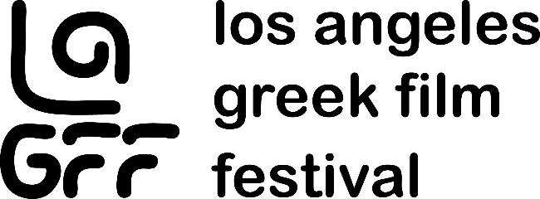

The 2020 Los Angeles Greek Film Festival Goes Virtual
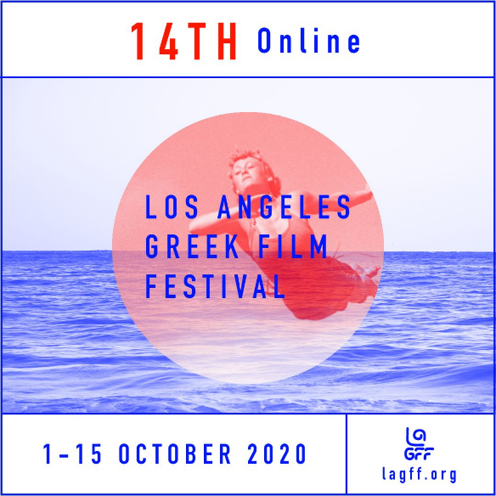
Artistic & Festival Director, Aristotle Katopodis has announced the 14th Annual Los Angeles Greek Film Festival (LAGFF) will be held on October 1-15, 2020. Due to the COVID-19 pandemic, LAGFF will run on-line and on-demand only. The virtual component allows this year’s Festival to reach a global audience. “With over 50 features, shorts, docs and animated films, LAGFF 2020 is the largest on-line Greek Film Festival outside of Greece. And, many films are making their North American, U.S. and West Coast premieres,” explains Katopodis.

LAGFF showcases new films from Greece and Cyprus, and includes works by international filmmakers of Greek descent. The Festival promotes Greek cinema, cultural exchange and helps to bridge the gap between filmmakers and Hollywood.
Several Masterclass webinars will be conducted by entertainment industry leaders including Chairman and Chief Executive Officer of Paramount Pictures Jim Gianopulos, Emmy Award-winning director Greg Yaitanes, and actress-producer Nia Vardalos.
Presenting sponsors of LAGFF 2020 are G.P. Kolovos & Associates and West Coast Investors.
Ticket Link - http://lagff.org/festival/tickets/
Festival Trailer - https://bit.ly/3iyVxRT
ABOUT: LAGFF is a 501 © (3) non-profit organization and open to all filmgoers and patrons of the arts. More info at www.lagff.org
FOLLOW US: @lagff on Facebook, Twitter, Instagram #LAGFF2020
MEDIA CONTACT: Melinda Manos, Manos Public Relations (310) 272-4225

